# GIT HANDSON-2

**Gitlab:** <https://gitlab.com/syamprasad-111-group/gitdemo>

.gitignore is a special file in a Git repository that tells Git which files or folders it should ignore.

This means Git will not track these ignored files, and they will not show up in git status, nor will they be added in commits.

How to ignore unwanted files step by step

Create a file named .gitignore in your project root: touch .gitignore

Open the file in your editor: notepad++ .gitignore

Add the patterns you want to ignore, for example:

*.log

*.tmp

backup/

Save and close the file.

Confirm what is being ignored: git status

Any files matching .gitignore will no longer show up as untracked.

**Step 1:** Open Git Bash and Navigate to Your Repo



**Step 2:** Create a Sample .log File and a log/ Folder

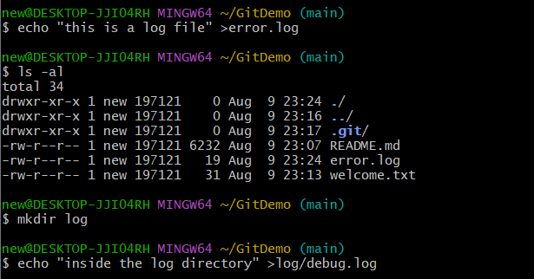

**Step 3:** Confirm Files Are Untracked by Git

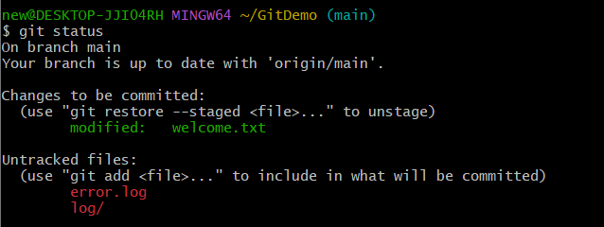

**Step 4:** Create a .gitignore File



**Step 5:** Edit .gitignore File to Ignore .log Files and log/ Folder



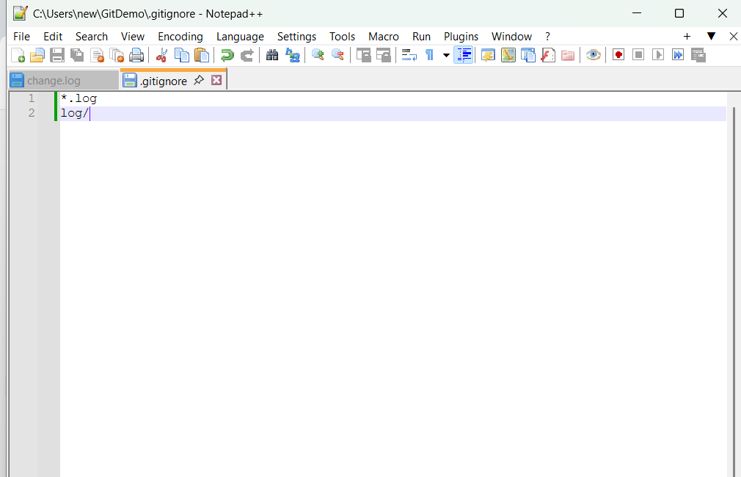

**Step 6:** Confirm Git Is Ignoring Those Files

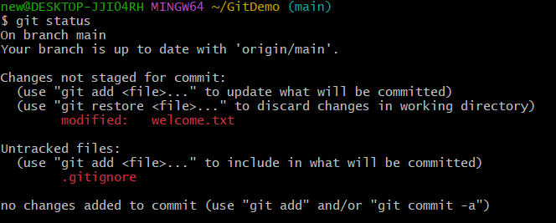

**Step 7:** Track and Commit .gitignore

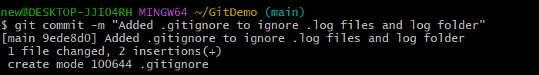

**Step 8**: Push to GitLab

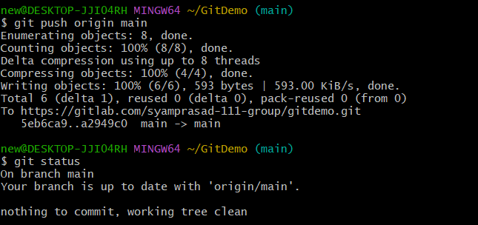  
  
**Step 9:** Verification

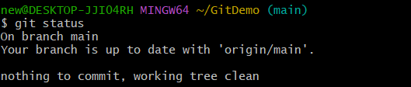

**Final “GitDemo” Repository:**  
